FAQ For G Flip2
- Basic Setting
- How can I change the language of the device?
- How can I check the IMEI number of my device?
- How can I check the device’s system version, model number, Platform version, and Build Number?
- How can I make a screenshot?
- How can I change the permissions for my apps?
- How do I change the wallpaper?
- How do I set a screen lock?

- Phone & Contact
- How can I answer a call?
- How can I silence the ringer of incoming calls?
- How can I make a three way calling?
- Where can I check recent call records?
- How can I switch to mute mode during a call?
- How can I add the number in a message to the contacts?
- How can I import contacts from the SIM card?

- Ringtone & Sounds
- How can I change the default ringtone and volume for incoming calls?
- How can I change ringtone to vibration?
- How can I set an MP3 as a ringtone?
- How can I change the ringtone of the alarm?

- Message
- How can I add an attachment in an MMS?
- How can I change the input method?

- Network & Connectivity
- How can I connect to a mobile network?
- How can I connect to a Wi-Fi network?
- How can I turn on Bluetooth and pair with another Bluetooth device?
- How can I change the name of my Bluetooth?

- Camera
- How can I take photos with the camera?
- Where can I check my photos?

- Music
- How can I play music?

- Email
- How can I create a POP3/IMAP email account?

- Reset
- How can I perform a factory reset on my phone?

- USB storage
- How to allow another computer or device connected using USB to access files on my phone?

- Troubleshooting
- What can I do when my phone pops up a warning saying “high temperature”?
- What can I do when a warning “the phone stops charging” pops up?
- What kinds of inappropriate phone using habit may cause battery potential risk?

- Basic Setting
- How can I change the language of the device?
Change language of your phone by accessing into main menu -> “Settings” -> “Personalization” -> “Language” -> choose the language you want.
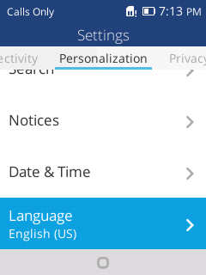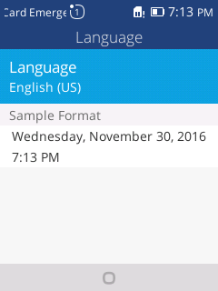

- How can I check the IMEI number of my Alcatel device?
You can check the IMEI information from the IMEI label which was stuck to the battery jar or battery cover, or by touching *#06# in dial keypad, or by going to main menu -> “Settings” -> “Device” -> “Device information” -> “More information” ->”IMEI”.
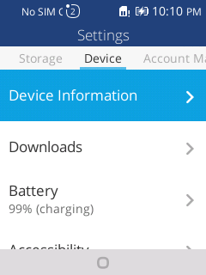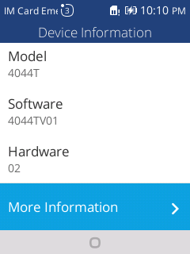
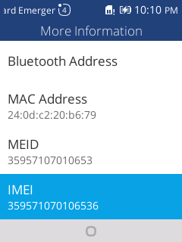

- How can I check the device’s system version, model number, Platform version, and Build Number?
You can check the information by accessing into menu “Settings” -> “Device” -> “Device information” -> “More information”.

- How can I make a screenshot?
Push camera button and Volume down button at the same time for a couple of seconds. You should then see an animation showing you the screenshot, and view the screenshot by tapping on the thumbnail in the notification tray or by visiting your Gallery application.
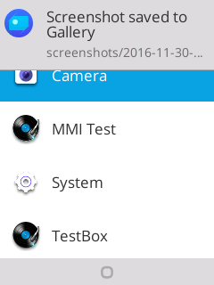
- How can I change the permission for my apps?
If an app supports the new permissions model on Android M, you don’t have to grant any permission when you install or update the app. Instead, the app requests permissions when needed.
You can change the “app permission” in the Settings >Privacy & Security> Apps permissions>select an app>Select individual permissions.
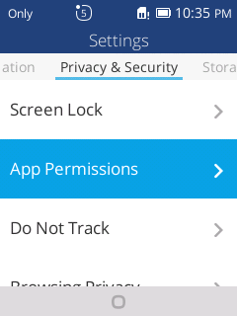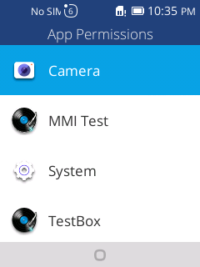
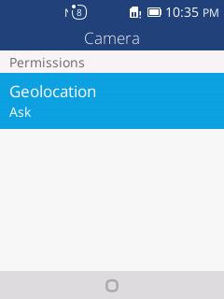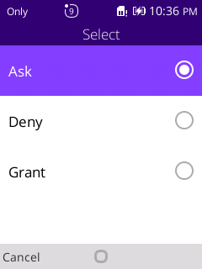

- How do I change the wallpaper?
You can set wallpaper by accessing menu-> “Settings” ->“Personalization” -> “Display” -> “Wallpaper”. Select a wallpaper source from “Wallpaper/Gallery/Camera”, select wallpaper as you like and save.
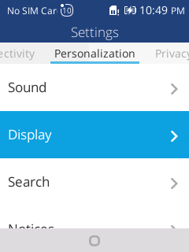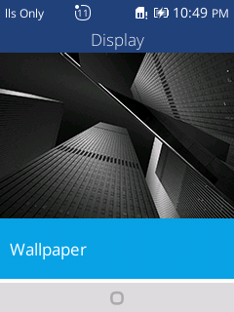
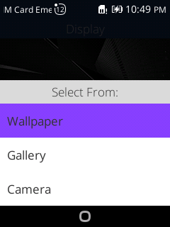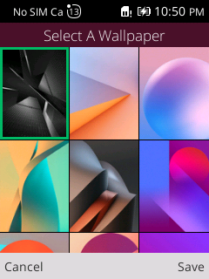
- How do I set screen lock?
In order to protect your personal information, you set screen lock by accessing menu-> “Settings” -> Privacy & Security> “Screen Lock” ->Select On->Create Password.
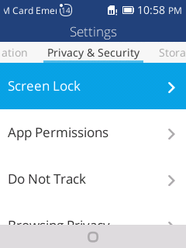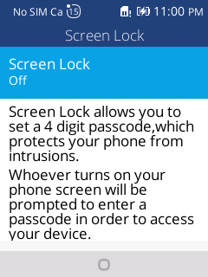
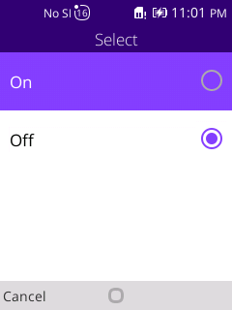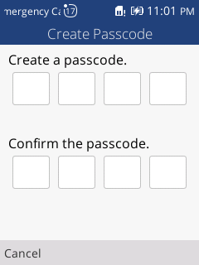
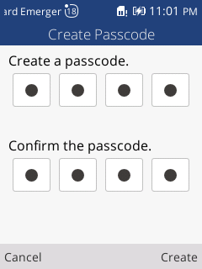

- Phone & Contact
- How can I answer a call?
When you receive a phone call, the incoming call screen opens. It shows caller ID and any additional information about the caller that you have saved in People app.

If there is any call missed, you will get a notice in notification bar or you can check all incoming call records in the call log tab of Phone app.
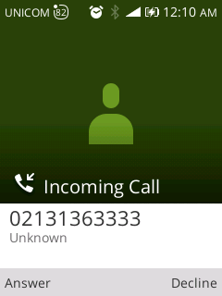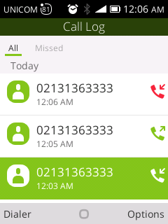

- How can I silence the ringer of incoming calls?
Press the Volume Down button on the side of your device until the “Silent” icon appears.
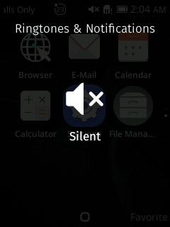

- How can I make a three way calling?
- Call the first person
- Touch “Add call”, then you can choose the second person you want to call.

- When you get though the second person, select “Merge call” to make a conference call.
*Notes: Three ways calling also need network/simcard support.
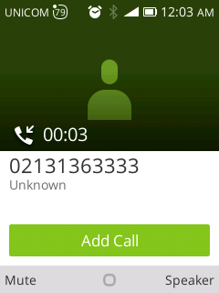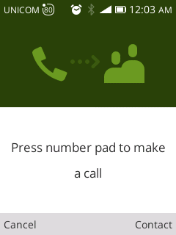

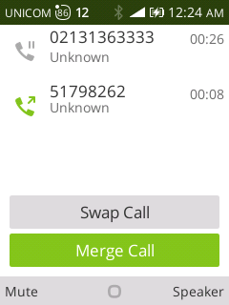

- Where can I check recent call records?
Access into menu->“Phone”->Call Log, you can check recent call records.
There’re three different color arrow icons which beside a call to indicate the type of calls.
Means missed incoming call
Means received incoming call
Means outgoing call

- How can I switch to mute mode during a call?
You can select “Mute” to mute your microphone.

- How can I add the number in a message to the contacts?
You can follow below steps to add numbers in a message to contacts by opening the message-> select the number-> Press OK-> Select “Create New Contact” ->Enter the name and related information ->Option->Press OK to save.
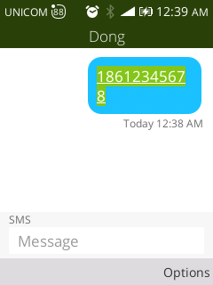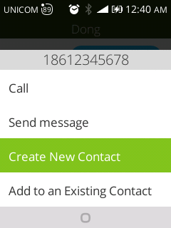
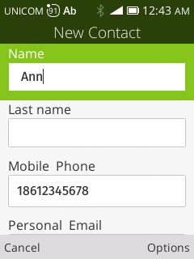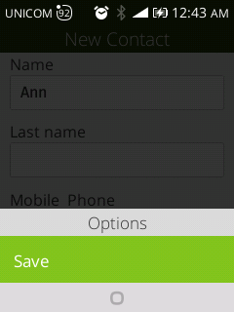

- How can I import contacts from SIM card?
You can import contacts from SIM card by accessing Menu->Contacts”->Options->Settings->Import Contacts->SIM card

- Ringtone & Sounds
- How can I change default ringtone and volume for incoming calls?
Change default ringtone for incoming calls
“Settings” -> ”Personalization” ->”Sound” ->”Tones” ->”Ringtones” ->Select a ringtone.
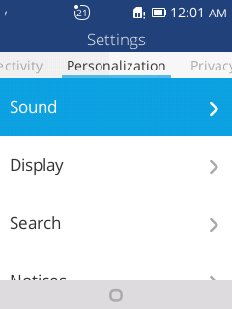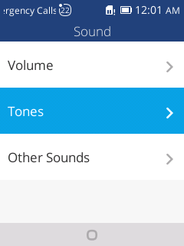
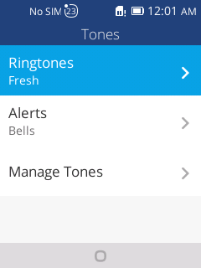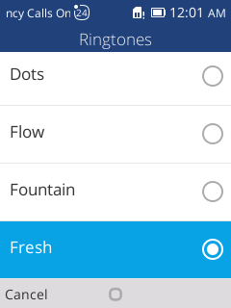

b. Change volume for incoming calls
“Settings” -> ”Personalization” ->”Sound” ->”Volume” ->Ringtones&Notification
You will see a Volume Bar. Press up and down key to adjust the volume.
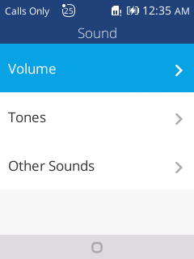
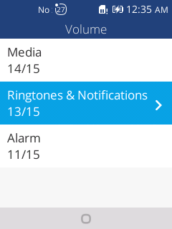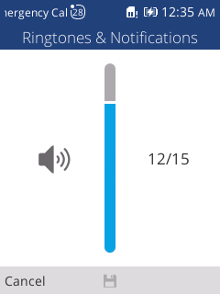

- How can I change ringtone to vibration?
To activate Vibrate, press the down volume key until you feel the phone vibrate.
To resume normal ringtone, press the up volume key.

- How can I set an MP3 as a ringtone?
Follow below steps to set an MP3 as phone ringtone.
- Open the “Music” app, you will see the music list
- Select the music that you want to set as ringtone, select “Option”. Then a list of options appears
- Select “Set as ringtone”->Select” Use as default ringtone”->Save. Your ringtone will be changed.
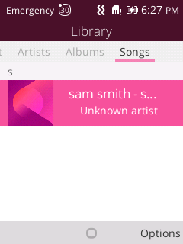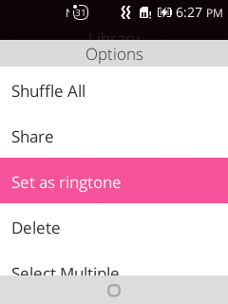
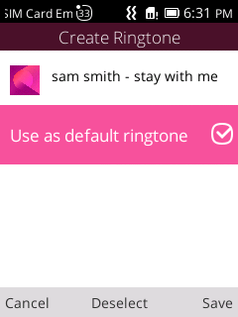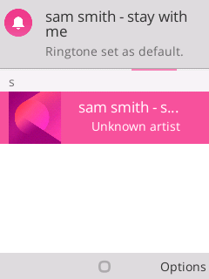

- How can I change the ringtone of the alarm?
Follow below steps to change the ringtone of alarm.
- Open “Clock” app.
- Select related alarm to get further setting.
- Select “Option”->Settings->Sound, then a list of ringtone appears.
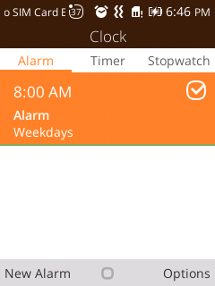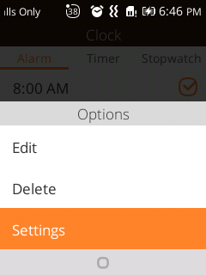
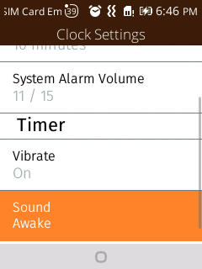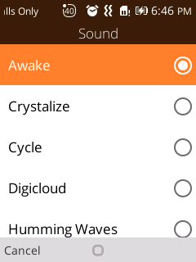
- Press up & down key to select and hear a ringtone, press OK to save changes.

- Message
- How can I add an attachment in an MMS?
- Press “Messaging” icon to open it
- Select “New Message” to create a new message
- Select “Option” to add attachment.
- Select what you want to attach in the new message.
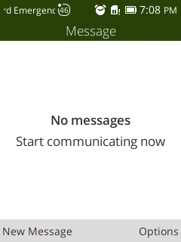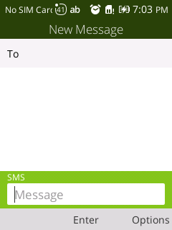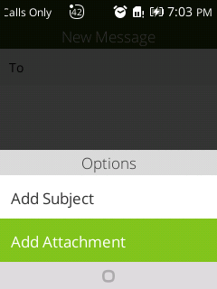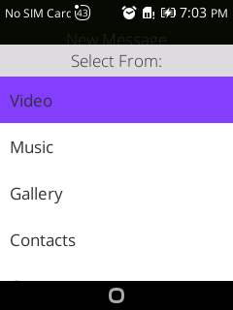

- How can I change the input method?
Change input method of your phone by accessing into menu -> “Settings” -> “Personalization” -> “Input methods” -> choose the Input method and language you want.
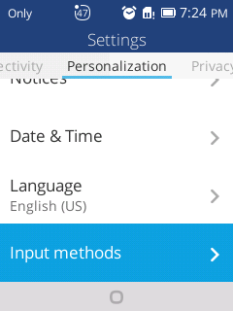

- Network & Connectivity
- How can I connect to a mobile network?
You can adjust mobile network settings by accessing into menu -> “Settings” ->Network & Connectivity -> Cellular & Data -> Carrier -> Network Type.
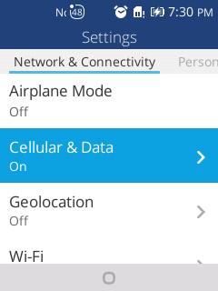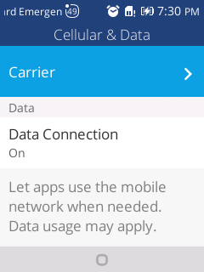
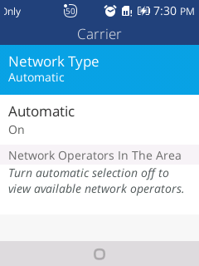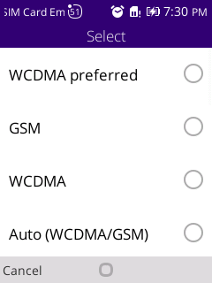

- How can I connect to Wi-Fi networks?
Wi-Fi is a wireless networking technology that can provide internet access at distances of up to 100 meters, depending on the Wi-Fi router and your surroundings.
To use Wi-Fi, you need to connect to a wireless access point, or “hotspot”. Some hotspots are open and you can connect to them easily. But others implement security features which require more steps to set up, like, digital certifications, passwords or other ways to ensure that only authorized users can connect.

Turn on Wi-Fi by accessing into menu -> “Settings” -> Network & Connectivity ->Wi-Fi
Select “On”, the device will scan for available networks and display the names, select “Available Networks” to see detail.
*Secured networks are indicated with a lock icon.
*If the device finds a network that you connected to previously, it will connects to it.
- Press up & down key to select a network name to see more details or connect to it.
- Enter a password or other credentials to connect network.
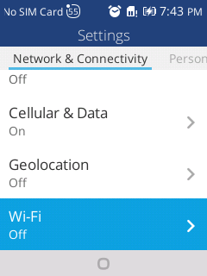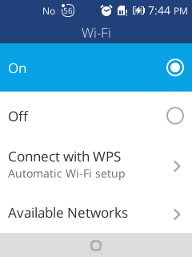
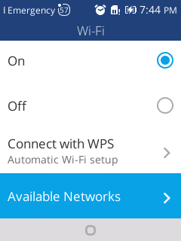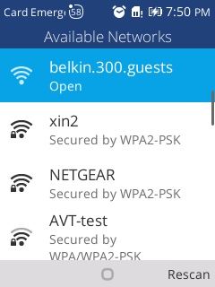

- How can I turn on Bluetooth and pair with another Bluetooth device?
Bluetooth is a short-range wireless communications technology used to communicate between devices over a distance of about 8 meters.
To connect to a Bluetooth device, you must turn on your phone’s Bluetooth radio. The first time you use a new Bluetooth device, you must pair it with the one you want to connect. Then both devices know how to connect securely to each other. After that, they connect automatically.
Turn on Bluetooth by accessing into menu -> “Settings” -> Network & Connectivity -> Bluetooth
- Select “On” for searching the device
- The device will scan for available devices and display the names, select “Devices in the Area” to see detail and select the device that you want to pair with.

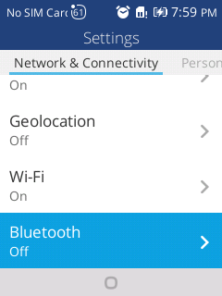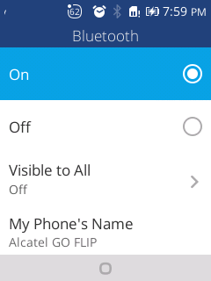
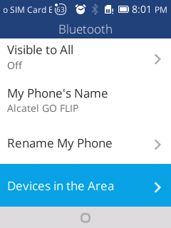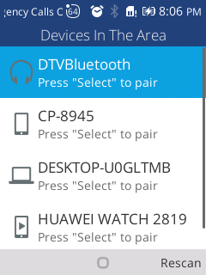

- How can I change the name of my Bluetooth?
You can follow below steps to rename the Bluetooth.
Turn on Bluetooth by accessing into menu -> “Settings” -> Network & Connectivity -> Bluetooth
- Select “On” for searching the device
- Select “Rename My Phone”, type the new phone name you want in the textbox and press save.
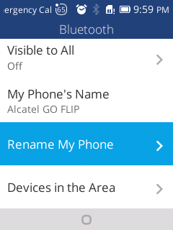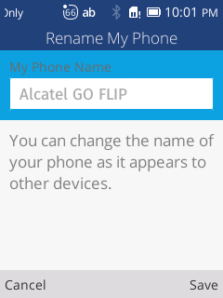

- Camera
- How can I take photos with camera?
Your Camera app is a combination of camera and camcorder.
You can follow below steps to take pictures and videos.
- Open “Camera” app in menu or press the camera side key.
- Press “OK” or the camera side key to take a photo.

Touch to take videos
- Where can I check my photos?
You can check your photos by visiting the Gallery app.

- Music
- How can I play music?
Open the “Music” app under main menu. You will find four libraries in which all songs are classified: Playlist, Artists, Albums and Songs. Choose the music you want and press OK to play.

- Email
- How can I create POP3/IMAP email account?
You can set up external POP3 or IMAP email accounts in your phone.
- Open “E-Mail” App, an email setup wizard will guide you through the steps to set up an email account.
- Enter the email address->select Manual Setup->choose the type of your account ->enter your password to sign in.
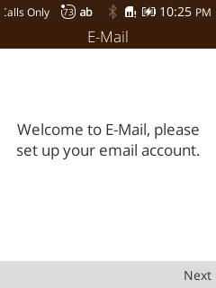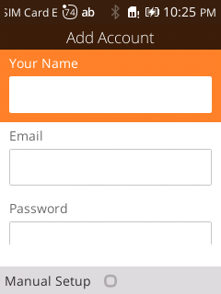
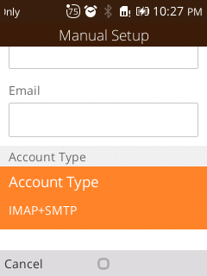
You can set up external Gmail accounts in your phone.
Pre: Enter 2-Step Verification page confirm Gmail account status.
URL:https://support.google.com/accounts/answer/185839
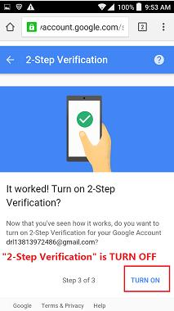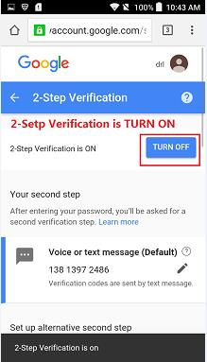
- If your Gmail account not turn on “2-Step Verification”
And must turn on the settings: “Allow account access for less secure apps”
Settings page: https://www.google.com/settings/security/lesssecureapps
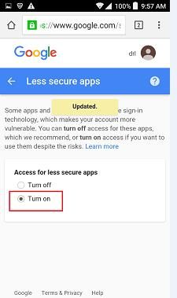
Login password use Gmail account password.
2) If your Gmail account turn on “2-Step Verification”
Enter to generate App-Passwords page: https://support.google.com/mail/answer/185833?hl=en
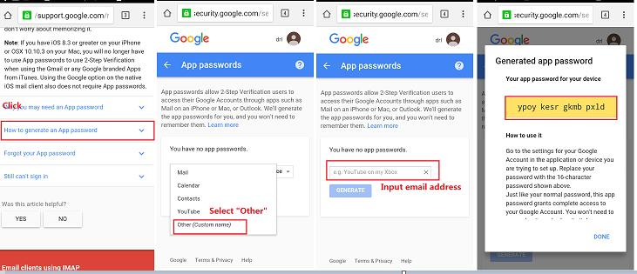
Login password must using Gmail App-Passwords.

3) Open “E-Mail” App, an email setup wizard will guide you through the steps to set up an email account.
Enter the email address and select Manual Setup to choose the type of your account and then enter your password to sign in.
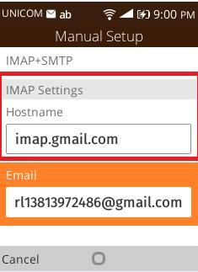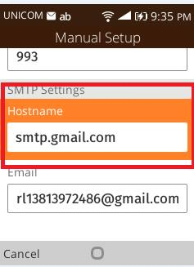
- Reset
- How can I perform a factory reset on my phone?
You can reset your device by accessing into menu -> “Settings” -> Device->Device Information->Factory Reset->Reset
Warning: this action will erase all your personal information and downloaded apps.
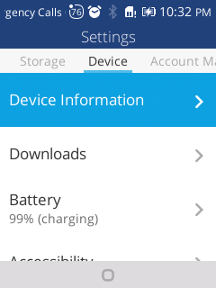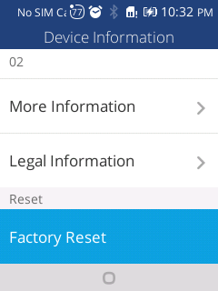
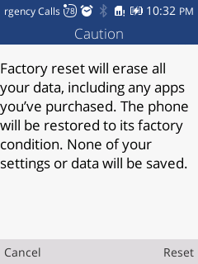

- USB storage
30. How to allow another computer or device connected using USB to access files on my phone?
You can enable USB storage by accessing into menu -> “Settings” -> “Storage” ->”USB Storage”->”Enabled”
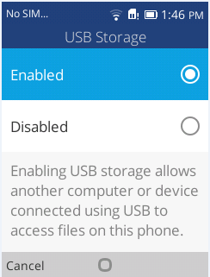

- Troubleshooting
- What can I do when my phone pops up a warning saying “high temperature”?
The warning is the normal consequence of the CPU handling excessive data, which makes battery warm. It is a recommendation message and not harmful to battery or phone even if the phone feels hot.
You can follow below actions to make phone return to normal temperature:
- It isn’t suggested to expose your phone in the sunshine for long time;
- Close large power consumption applications, such as music , chatting applications, GPS application, 3D gaming, video streaming etc.;
- Reduce the brightness of screen to lower the temperature

- What can I do when a warning “the phone stops charging” pops up?
The warning is a normal recommendation message and it isn’t harmful for battery or phone. Phone will start recharging once returning to normal temperature.
You can follow below actions to make phone return to normal temperature:
- It isn’t suggested to expose your phone in the sunshine for long time;
- Close large power consumption applications, such as music , chatting applications, GPS application, 3D gaming, video streaming etc.;
- Reduce the brightness of screen to lower the temperature

- What kinds of inappropriate phone using habit may cause battery potential risk?
- Not use the ALCATEL ONETOUCH charger.
- Use your phone near heat source.

